Database Assignment

* 1. What does DML stand for?

Data manipulation language

* 1. List the core DML statements that allow you to manipulate data is any SQL server table?

Insert, update, delete, select

* 1. What does DDL stand for?

Data definition language

* 1. What is DDL used for?

DDL is used to create tables, views, indexes, schemes and to change tables or to drop tables

Part B: In SQL Server Express, create a database called Soccer. In the database, create a table called Clubs

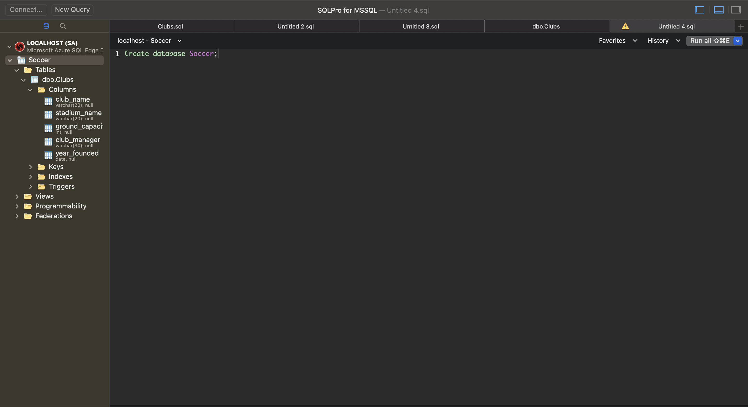

Create a Table

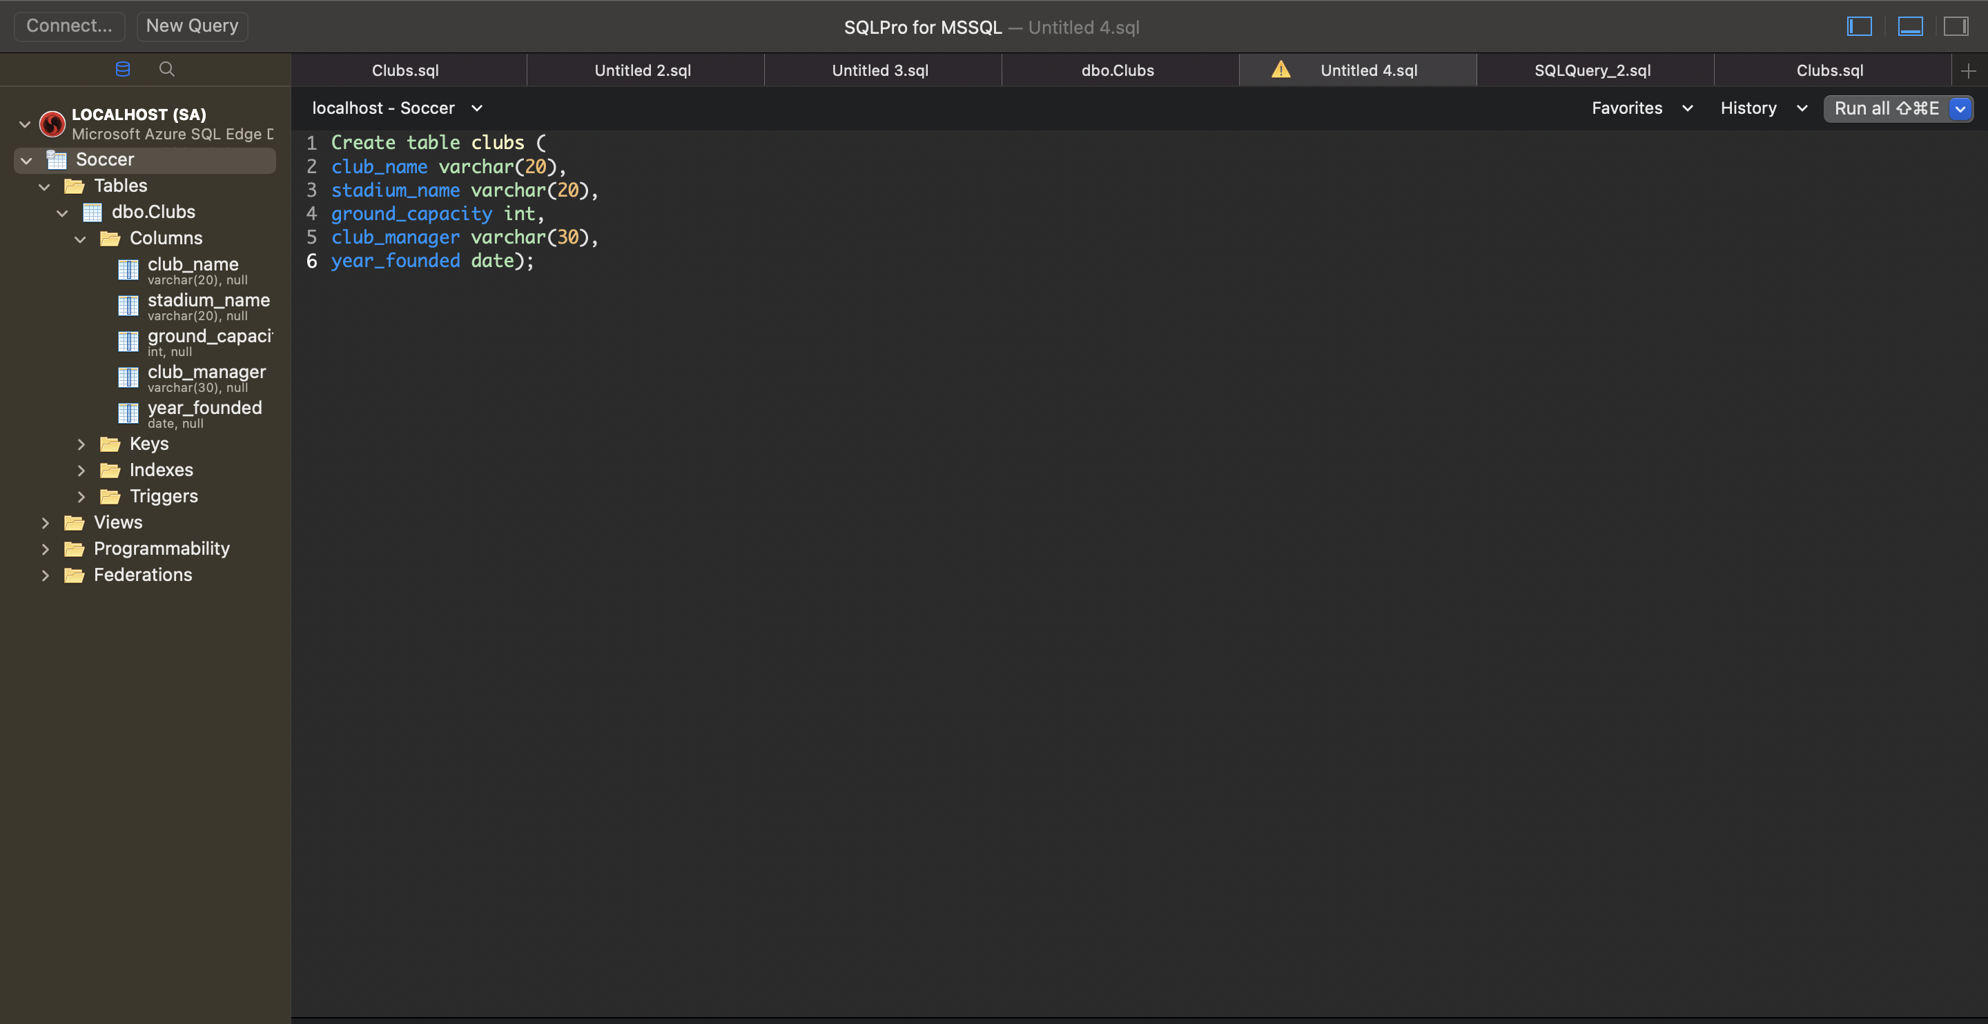

Inse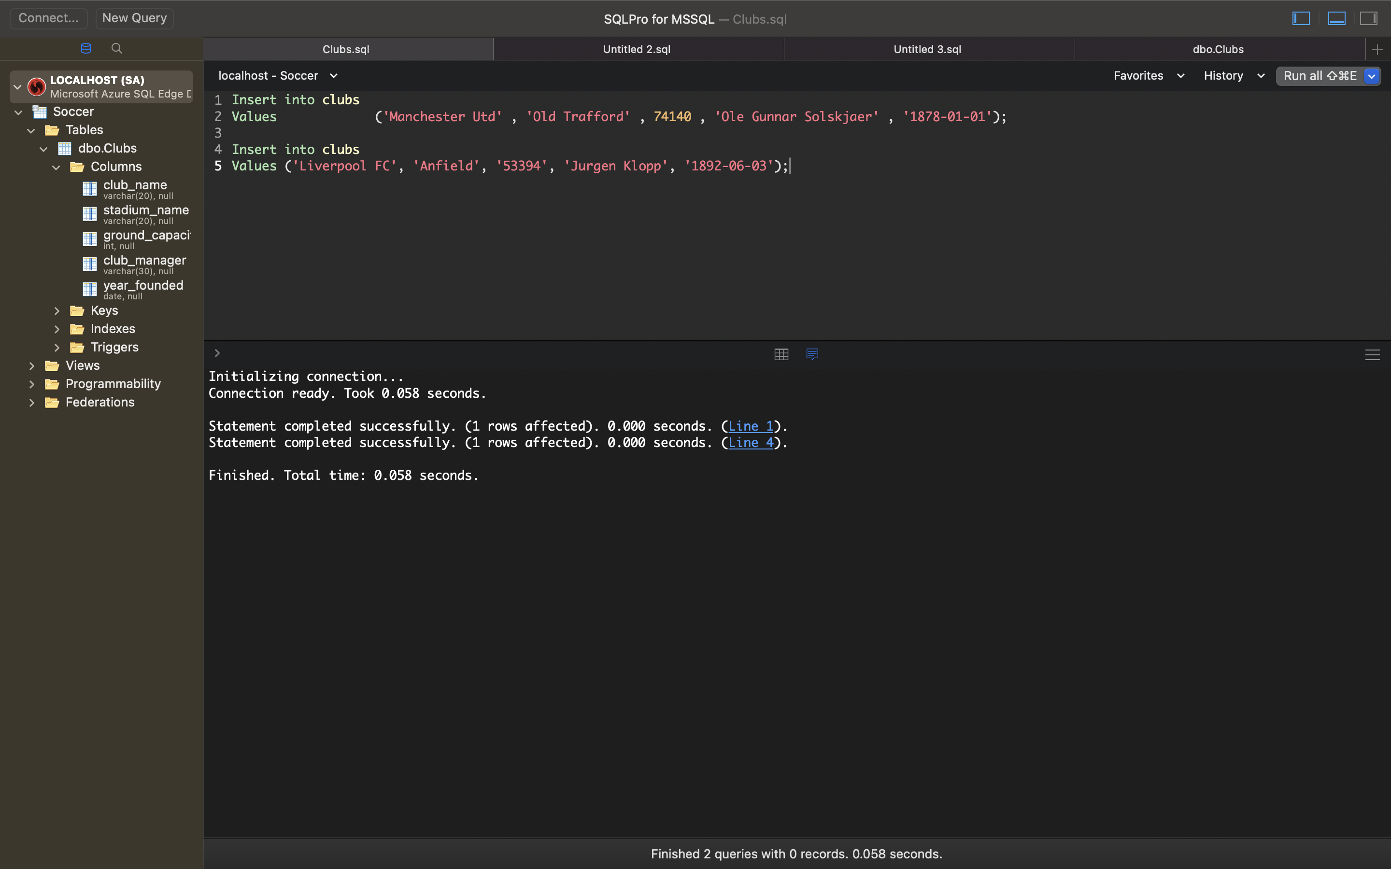rt records into the table

Update th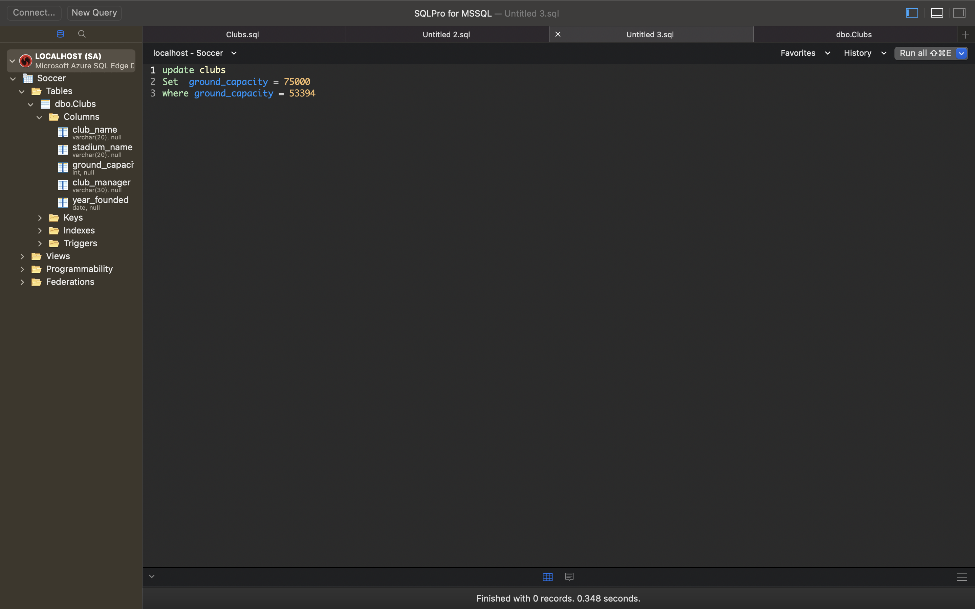e table

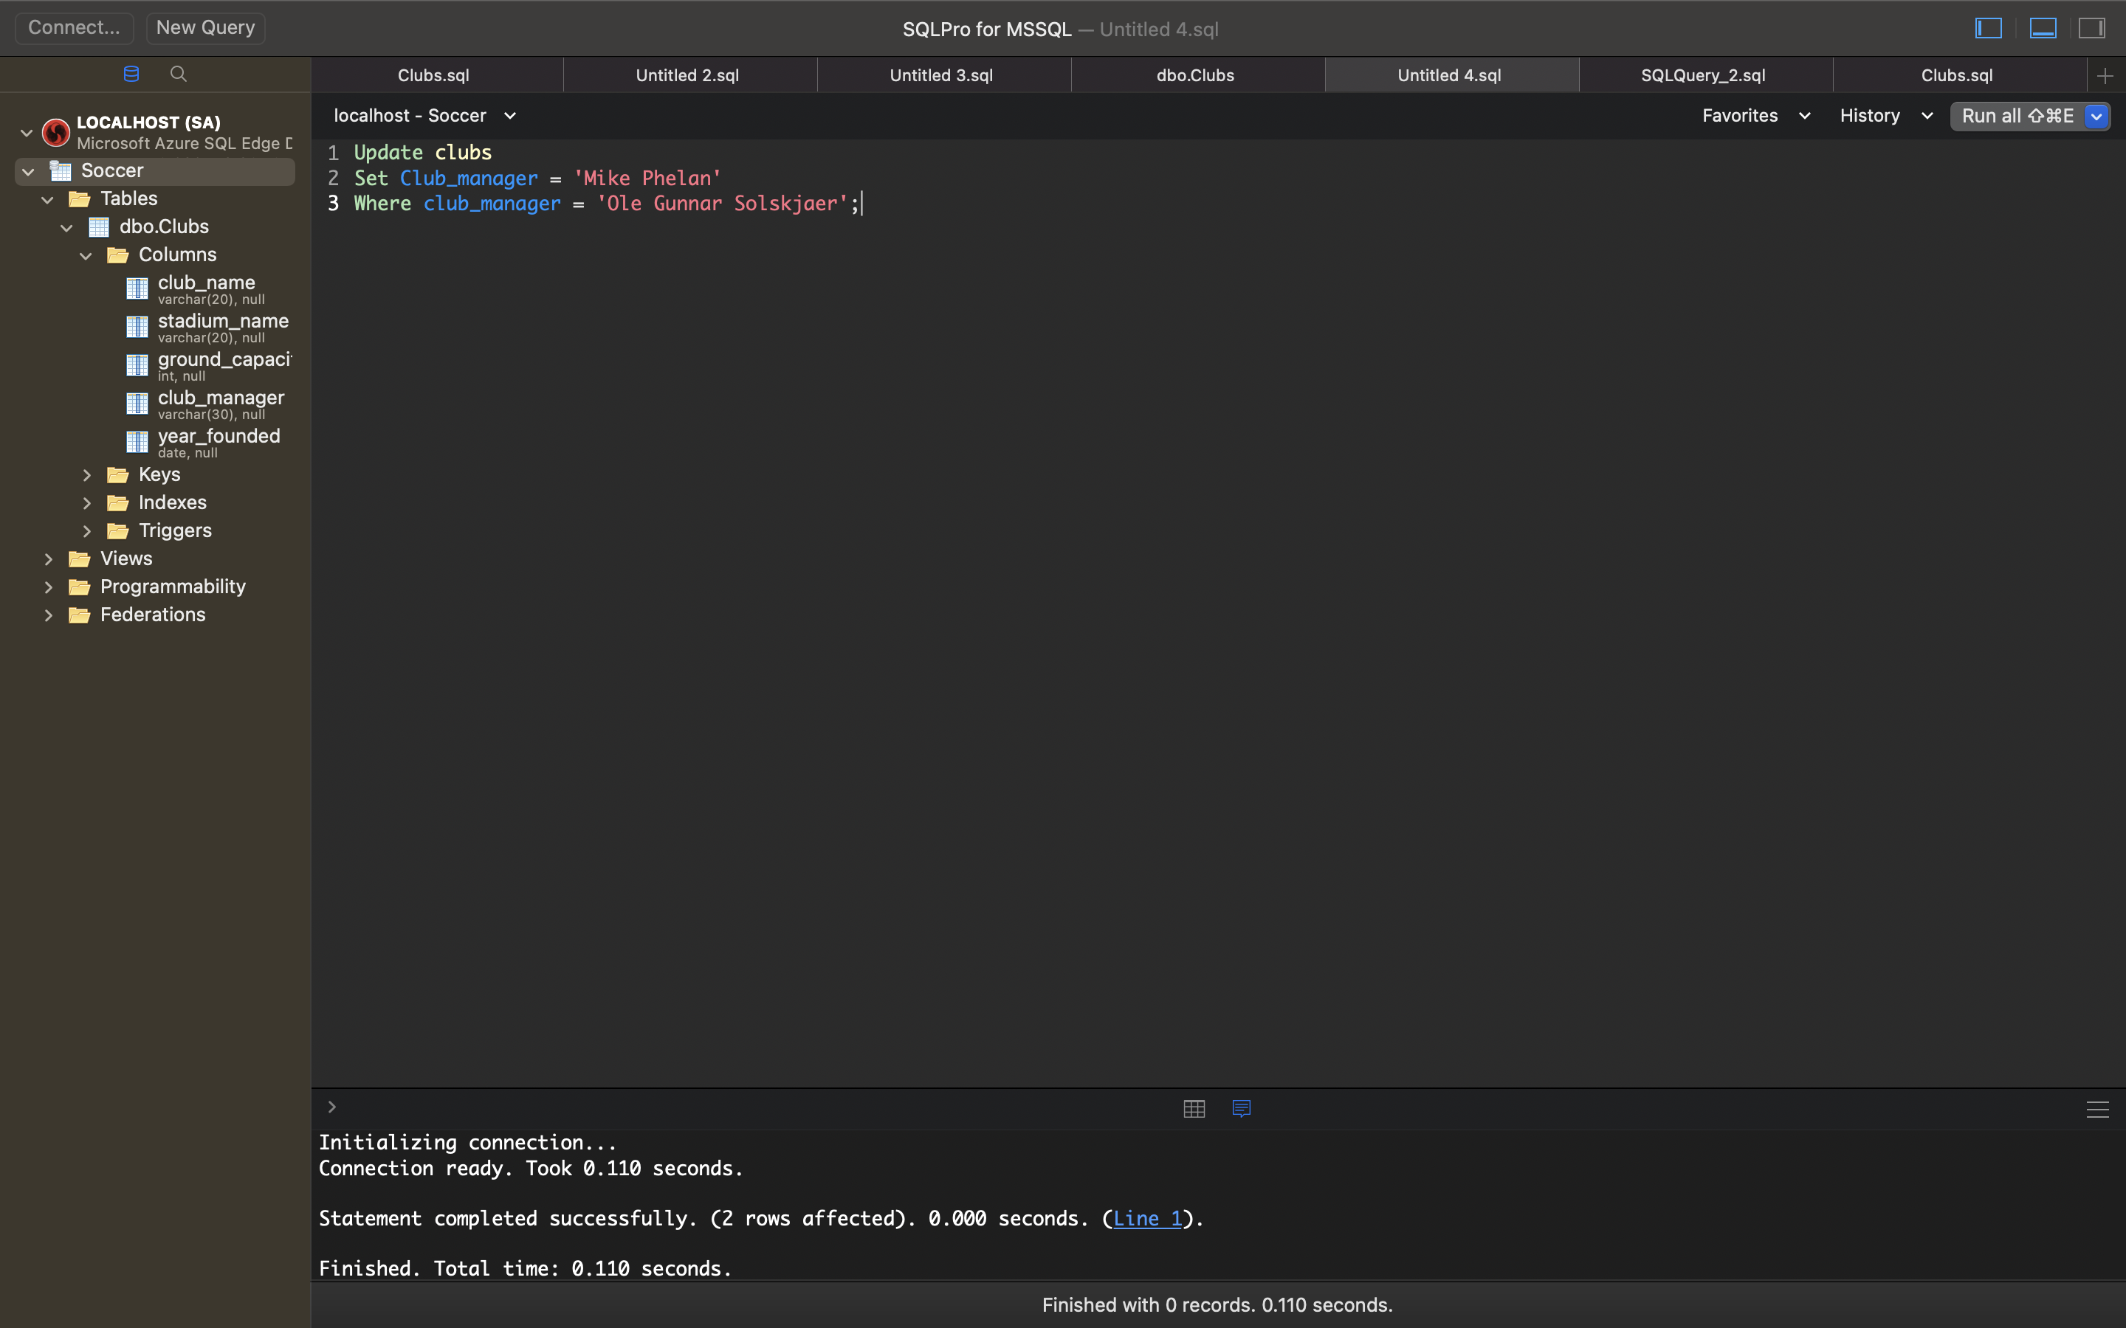

***Delete record from table***

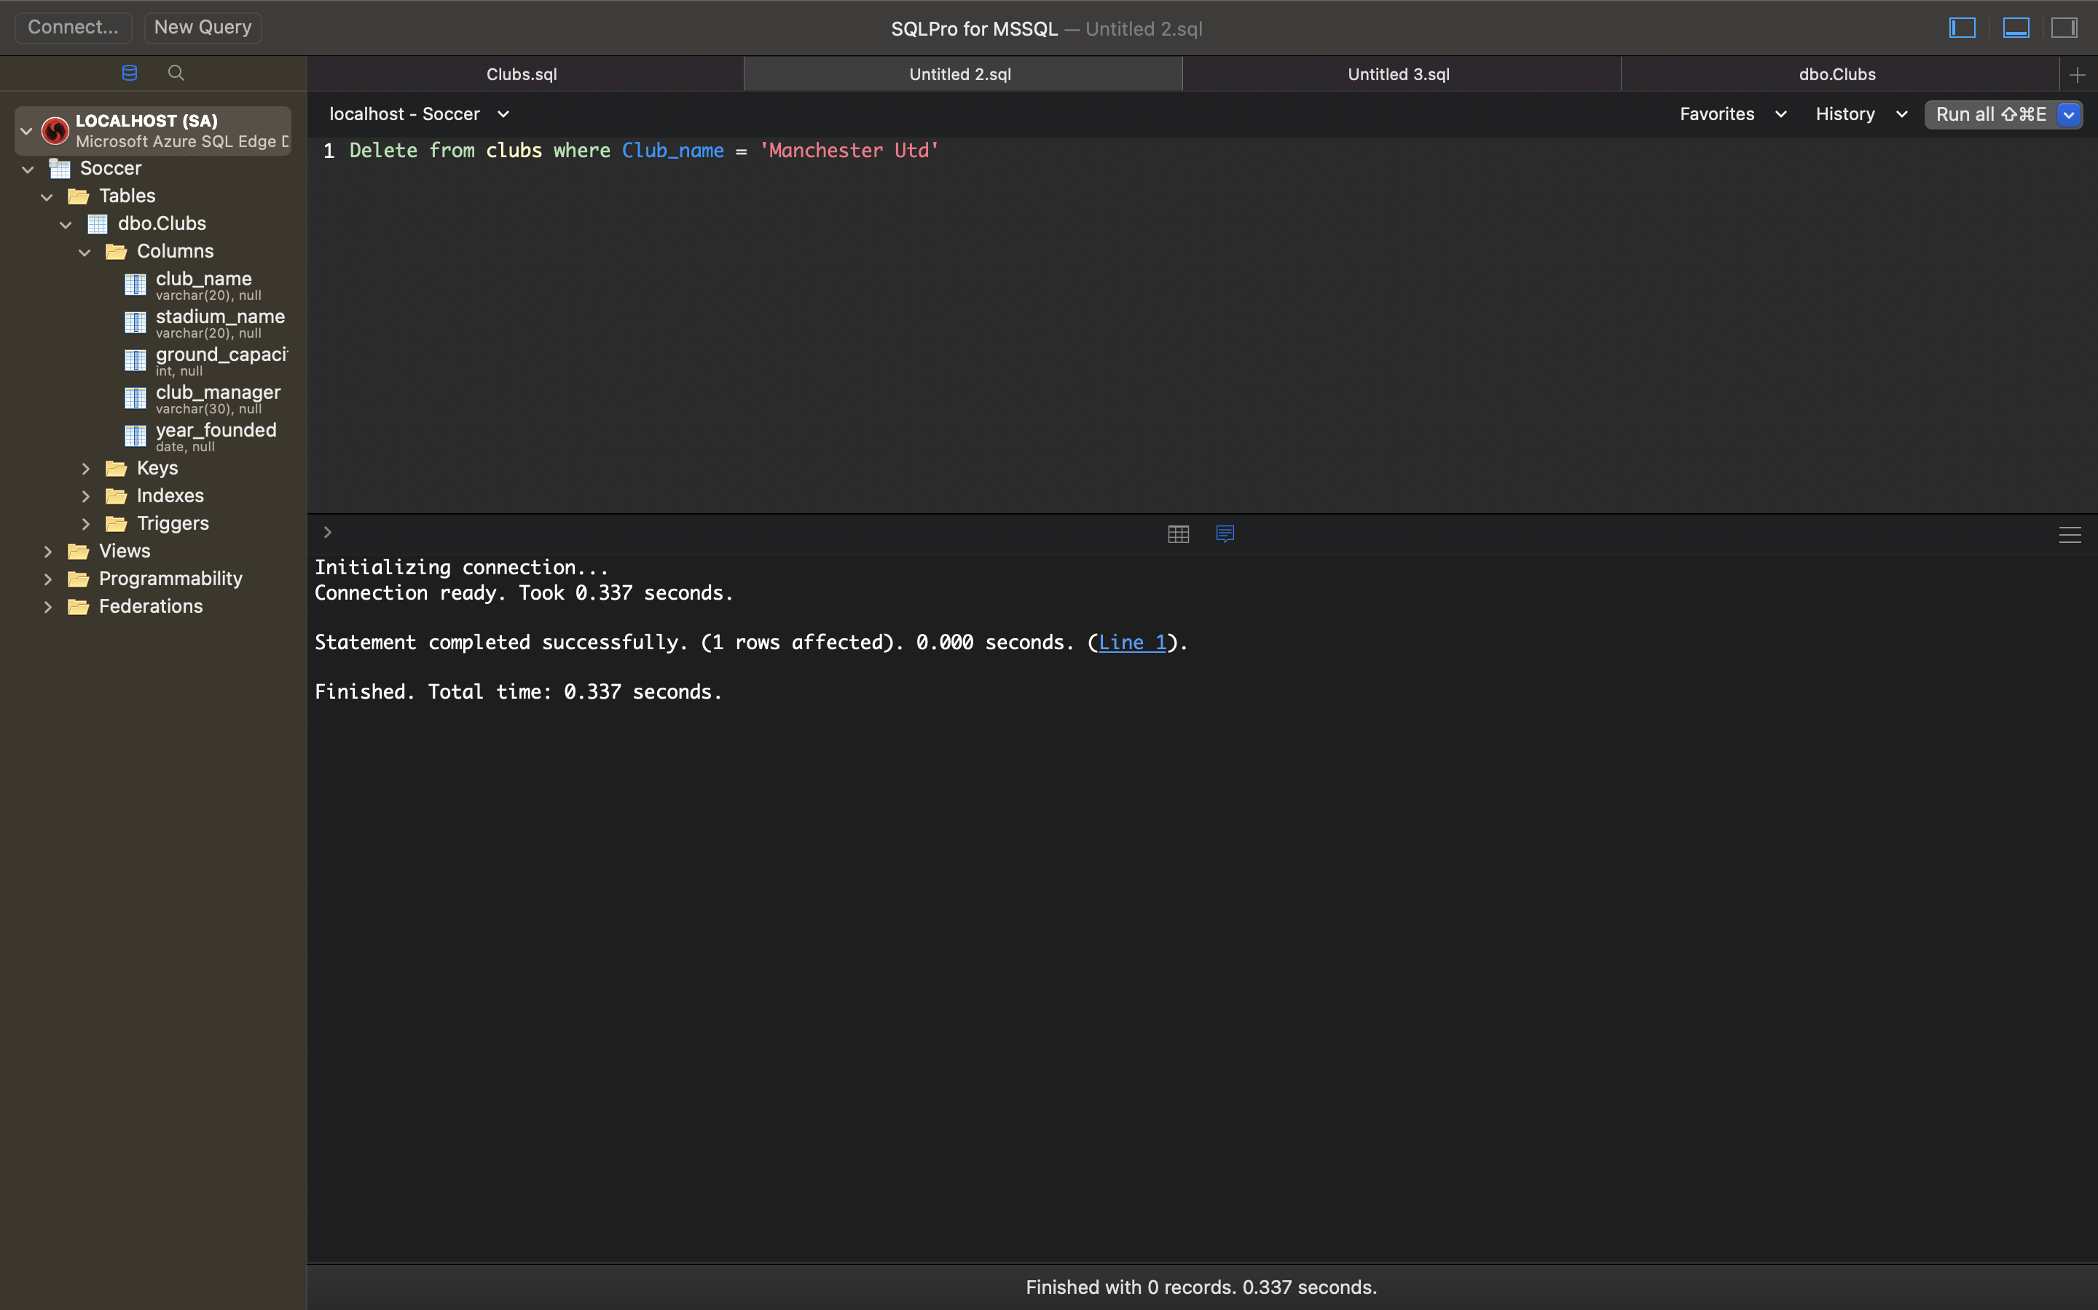

A query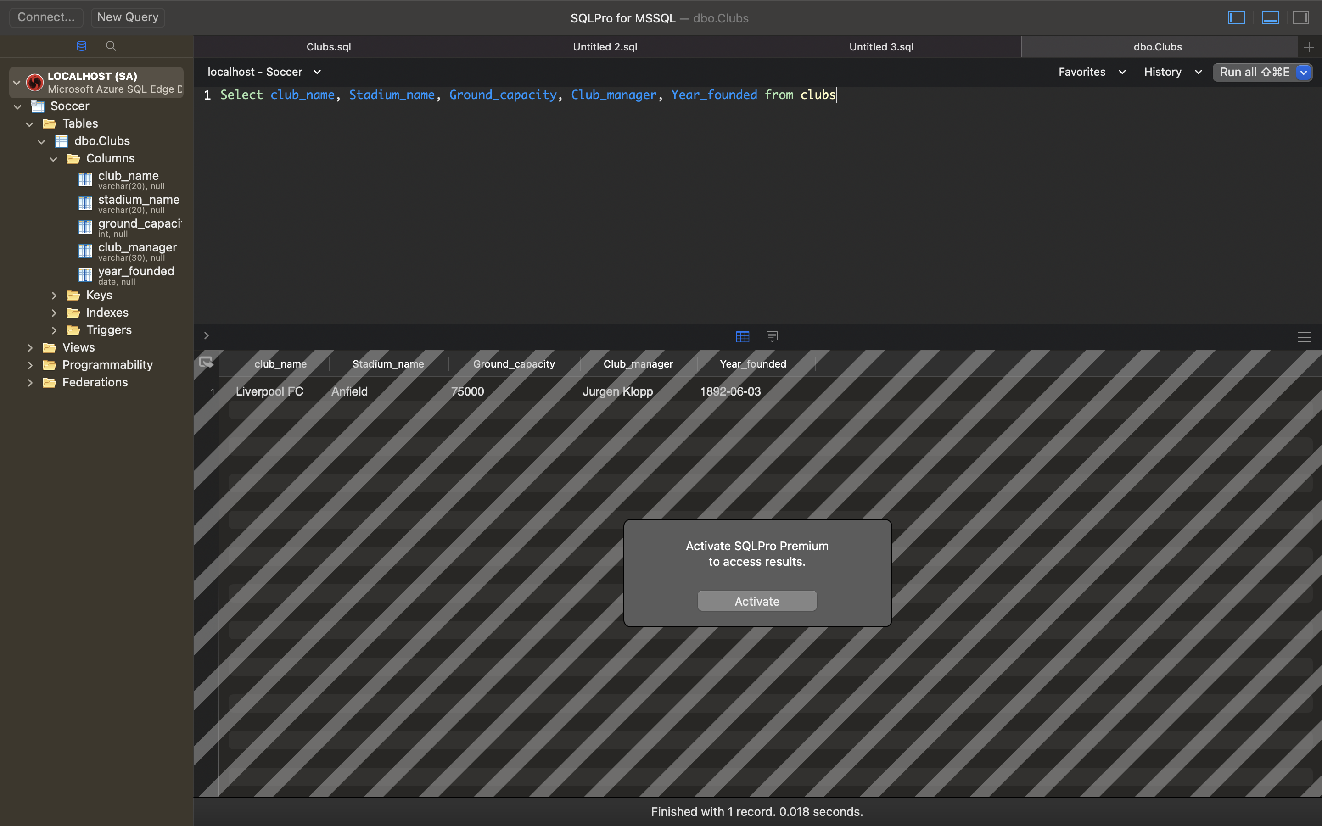 to show all the records in the table